**ORCHID INTERNATIONAL COLLEGE**

**SET A**

**Bijaychowk, Gaushala-9, Kathmandu**

**Full Marks: 60**

**Time: 3hrs**

**Pre-Board Examination -2081**

**BIM /Fourth Semester / IT 220: Database Management Systems**

***Candidates are required to answer the question in their own words as far as practicable.***

## Group “A”

### Brief Answer Questions [10 × 1 = 10]

1. What is a derived attribute?
2. Define normalization.
3. Write the general syntax to add a tuple using DML statement in a database.
4. Define union Operation.
5. What is a closure?
6. What is the difference between ORDER BY clause and LIMIT clause?
7. What is a Shared Lock?
8. What do you mean by Distributed Database?
9. List any two differences between RDBMS and NoSQL .
10. What do mean by a COMMIT and ROLLBACK?

## Group “B”

**Short Answer Questions (Any Five) [5 × 3 = 15]**

1. Explain three tier architecture.
2. Demonstrate CROSS JOIN through any example.
3. Describe selection in a relational algebra using any suitable example.
4. What are the advantage and limitation of NoSQL Database?
5. List and explain various States of Transaction.
6. Prepare an ER model for food ordering system. Assume any necessary entities and attributes. List all the assumptions made.

## Group “C”

**Long Answer Questions (Any Three) [3 × 5 = 15]**

1. Explain 2PL. Write down the algorithm of Timestamping Ordering Protocol.
2. What are aggregate functions used for in SQL? List any four aggregate functions and explain their usage.
3. What are various constraints in a relational database? Explain them, through any example of your own choice.
4. Explain Query Processing. What is Query Optimization?

## Group “D”

# Comprehensive Answer Questions [10 × 2 = 20]

1. Using the following Relational Model of the schema:

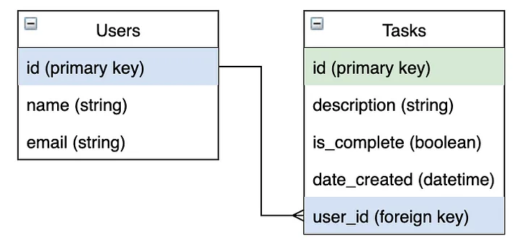

1. Write the **RA** to find the tasks done by “Radhika” but not by “Priti”.
2. Write SQL to find the list of users who haven’t completed any of their tasks allocated to them.
3. Write SQL to find the total number of tasks allocated to user ID 112 within FY 2021.
4. Write SQL statement to find the name of the User who have completed more than 20 tasks in the FY 2022.
5. Write SQL statement to find the name of the user whose email starts with ‘tu’ but the third last character is ‘e’.
6. Normalize the following database up to BCNF.

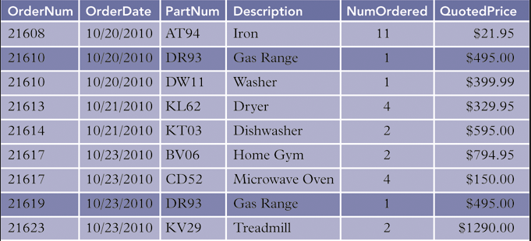

**ORCHID INTERNATIONAL COLLEGE**

**SET B**

**Bijaychowk, Gaushala-9, Kathmandu**

**Full Marks: 60**

**Time: 3hrs**

**Pre-Board Examination -2081**

**BIM /Fourth Semester / IT 220: Database Management Systems**

***Candidates are required to answer the question in their own words as far as practicable.***

## Group “A”

### Brief Answer Questions [10 × 1 = 10]

1. What is the use of multi valued attribute?
2. Define BCNF.
3. Write the general syntax to remove a column using DDL statement in a database.
4. Define Isolation, and Consistency property of a transaction.
5. Differentiate Candidate key and Super Key?
6. What is the difference between Central and Distributed Database Architecture?
7. What is the purpose of Selection operator in Relational Algebra?
8. What is Shared/Exclusive Lock?
9. Explain Discretionary and Mandatory Access Control in DBMS.
10. What is the role of REDO/UNDO Operation in DBMS?

## Group “B”

**Short Answer Questions (Any Five) [5 × 3 = 15]**

1. Explain areas of application of DBMS
2. What are various constraints? Explain any two of them.
3. Describe union and intersection operation using any suitable example of your own choice.
4. What are the advantage and limitation of NoSQL databases and Distributed databases?
5. Explain Aries Algorithm.
6. Prepare an ER model for an online Scholarship Application and Distribution System. Assume any necessary entities and attributes. List all the assumptions made.

## Group “C”

**Long Answer Questions (Any Three) [3 × 5 = 15]**

1. Explain through any example of your own choice, the results of natural Join and INNER JOIN between two relations. Assume data on your own and finally deduce the resultant relation.
2. What are the uses of BETWEEN and IN operator in SQL? List any four aggregate functions and explain their usage.
3. Explain Binary Locking and Shared/Exclusive Locking Protocol.
4. What is a schedule? Differentiate Serial Schedule and Serializable Schedule through any example.

## Group “D”

# Comprehensive Answer Questions [10 × 2 = 20]

1. Using the following Relational Model of the schema:



1. Write the RA to find the tasks done by “Radhika” but not by “Pratima” in March of 2023.
2. Write SQL to find the list of users who have not been assigned any task related with “Muktinath Pharmacheuticals”.
3. Write SQL to find the name of students who have completed the highest number of tasks.
4. Write SQL statement to create a view to find the list of users and their active tasks.
5. Write SQL statement to find the name of the user whose email has ‘pit’ and doesn’t ends with ‘oic.edu.np’.
6. Normalize the following database up to BCNF.

